Practical 7: PHP Form Processing with Server-Side Validation and CSV/JSON File Storage
Problem Definition | Process submitted registration/contact form data using PHP. Validate and sanitize inputs on the server side and store records in CSV or JSON file format. Display success/error messages.
A. Theory
1. Is the form submitted using POST?
Answer: Yes. The form data is received using the POST method and processed on the server.
2. Are inputs validated and sanitized server side?
Answer: Yes. Required fields are checked and the input values are sanitized before storing or displaying them.
3. Is file writing handled safely?
Answer: Yes. The submitted data is converted into JSON and stored in a JSON file using PHP file handling functions.
4. Are success and error responses displayed clearly?
Answer: Yes. A success message is shown when the data is stored correctly, and an error message is shown if saving fails.
B. Implementation / Output / Result
<?php

if ($_SERVER["REQUEST_METHOD"] == "POST") {

$name = htmlspecialchars(trim($_POST["name"] ?? ""));
$gender = htmlspecialchars(trim($_POST["gender"] ?? ""));
$student_id = htmlspecialchars(trim($_POST["student_id"] ?? ""));
$mobile = htmlspecialchars(trim($_POST["mobile"] ?? ""));
$college = htmlspecialchars(trim($_POST["college"] ?? ""));
$branch = htmlspecialchars(trim($_POST["branch"] ?? ""));
$address = htmlspecialchars(trim($_POST["address"] ?? ""));

$hobbies = $_POST["hobbies"] ?? [];

if ($name == "" || $student_id == "" || $mobile == "") {
echo "<h2>Error: Please fill all required fields.</h2>";
exit;
}

$file = "student.csv";

$fileExists = file_exists($file);
$handle = fopen($file, "a");

if ($handle) {

if (!$fileExists || filesize($file) == 0) {
fputcsv($handle, [
"Name",
"Gender",
"Student ID",
"Mobile",
"College",
"Branch",
"Address",
"Hobbies"
]);
}

fputcsv($handle, [
$name,
$gender,
$student_id,
$mobile,
$college,
$branch,
$address,
implode(", ", $hobbies)
]);

fclose($handle);

echo "<h1>Form Submitted Successfully!</h1>";

echo "<p><b>Name:</b> $name</p>";
echo "<p><b>Gender:</b> $gender</p>";
echo "<p><b>Student ID:</b> $student_id</p>";
echo "<p><b>Mobile:</b> $mobile</p>";
echo "<p><b>College:</b> $college</p>";
echo "<p><b>Branch:</b> $branch</p>";
echo "<p><b>Address:</b> $address</p>";
echo "<p><b>Hobbies:</b> " .
(!empty($hobbies) ? implode(", ", $hobbies) : "None") .
"</p>";

echo "<p>Data saved successfully in students.csv</p>";

} else {
echo "<h2>Error: CSV file could not be opened.</h2>";
}

} else {
echo "Invalid Request.";
}

?>

C. Evidence of Work (Screenshots)
––––––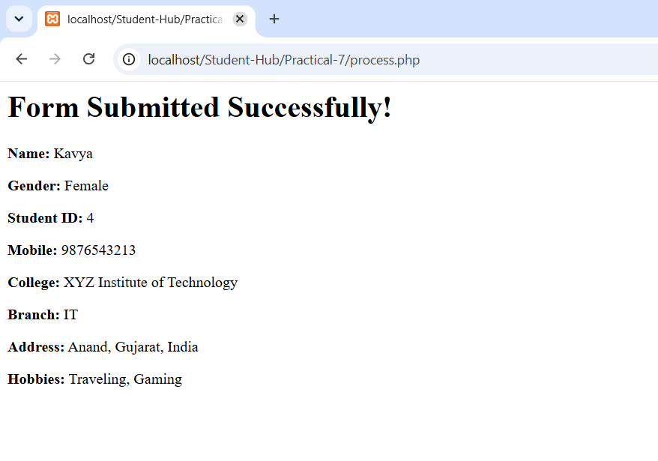
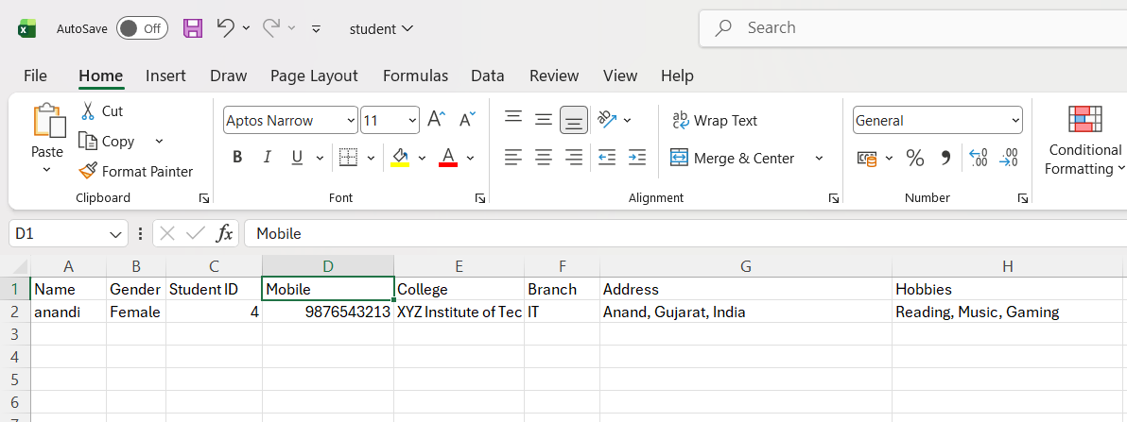
D. GitHub Repository Link:
https://github.com/AD-9218/Student-Hub/tree/main/Practical-7
E. Challenges Faced:
I faced a problem while running PHP in XAMPP because the “Not Found” error was displayed. I solved this problem by placing my project folder inside the htdocs folder. After that, the PHP file worked correctly.
Form Submitted Successfully!
Name: Not received
Gender: Not received
Student ID: Not received
Mobile: Not received
College: Not received
Branch: IT
Address: Not received
Hobbies: None
Not Found
The requested URL was not found on this server.

Apache/2.4.58 (Win64) OpenSSL/3.1.3 PHP/8.2.12 Server at localhost Port 80
Learning Outcomes:
I learned how to process form data using PHP and the POST method. I also learned server-side validation, input sanitization, and storing data in a JSON file.
Faculty Remarks:

